- List 3 real-world devices in your home or college that use SMPS (Switched Mode Power Supply) and 2 devices that use UPS (Uninterruptible Power Supply), explaining in one line why each device needs that type of power supply.
Answer:

Devices Using SMPS (Switched Mode Power Supply)
- Laptop charger: Converts AC power from the wall socket into the required DC voltage to charge the laptop battery.
- Desktop computer: Converts AC power into different DC voltages required by the motherboard, CPU, and other components.
- Mobile phone charger: Converts AC power into low-voltage DC power to charge the phone safely.

Devices Using UPS (Uninterruptible Power Supply)
- Desktop computer: A UPS provides temporary backup power during a power cut, allowing the user to save work and shut down safely.
- Wi-Fi router: A UPS keeps the router running during a power outage so that the internet connection can remain available, provided the network connection itself is still active.

- Draw and label a diagram showing the main internal components of a typical SMPS unit found in a desktop PC, including AC input, rectifier, transformer, and DC output sections. Hint: You can hand-draw and upload a photo, or use any free diagram tool like draw.io.
Answer:
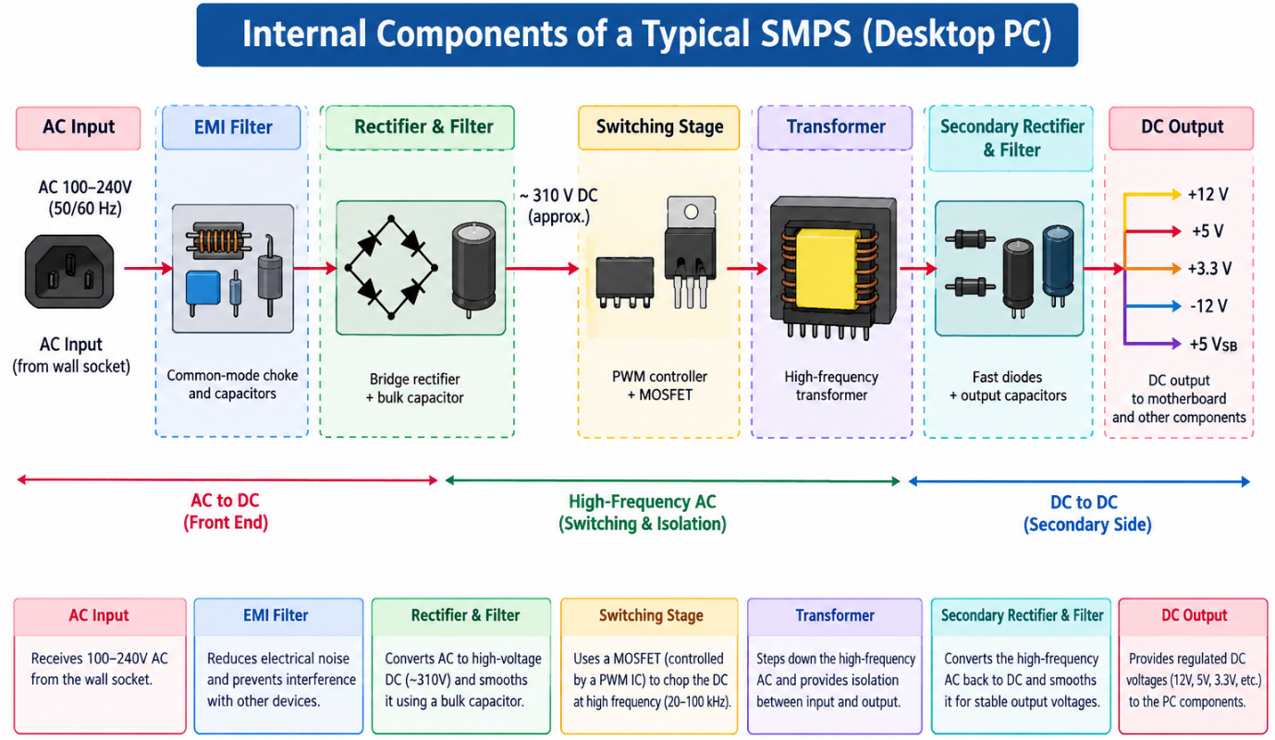
Main components included:
- AC input
- EMI filter
- Bridge rectifier and filter capacitor
- Switching circuit (MOSFET and PWM controller)
- High-frequency transformer
- Secondary rectifier and filter
- DC output voltages

- Take photos or find clear images online of the following power connectors: ATX 24-pin motherboard connector, SATA power connector, Molex connector, and PCIe 6/8-pin connector. For each, write its name, the devices it powers, and one safety tip for connecting/disconnecting it.
Answer:

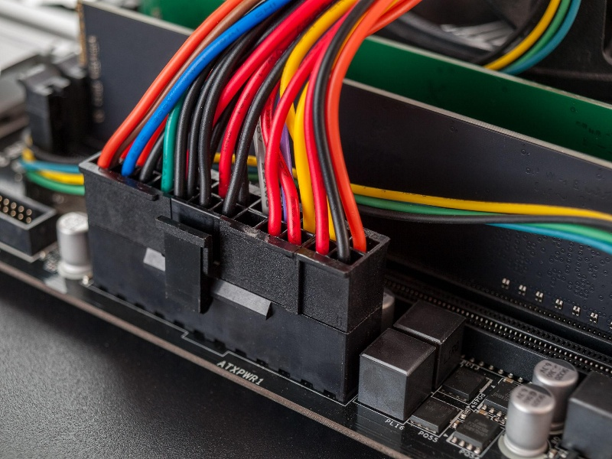
  - ATX 24-pin motherboard connector:
Devices powered: Motherboard and its main power circuits.
Safety tip: Align the connector with the motherboard socket and press until the locking clip clicks. Never force it.

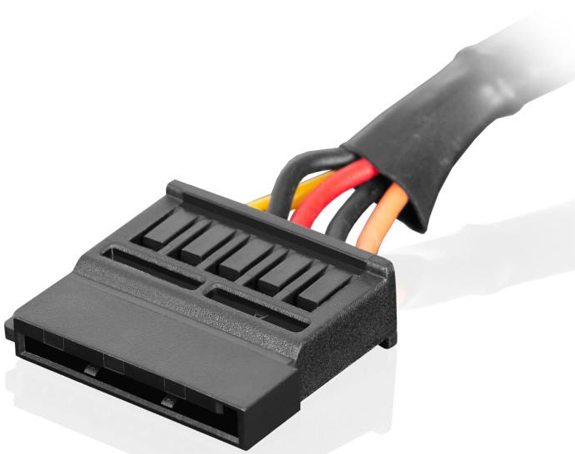
  - SATA power connector:
Devices powered: SATA hard disk drives (HDDs), solid-state drives (SSDs), and SATA optical drives.
Safety tip: Switch off and unplug the PC before connecting or disconnecting it; align the L-shaped connector correctly.

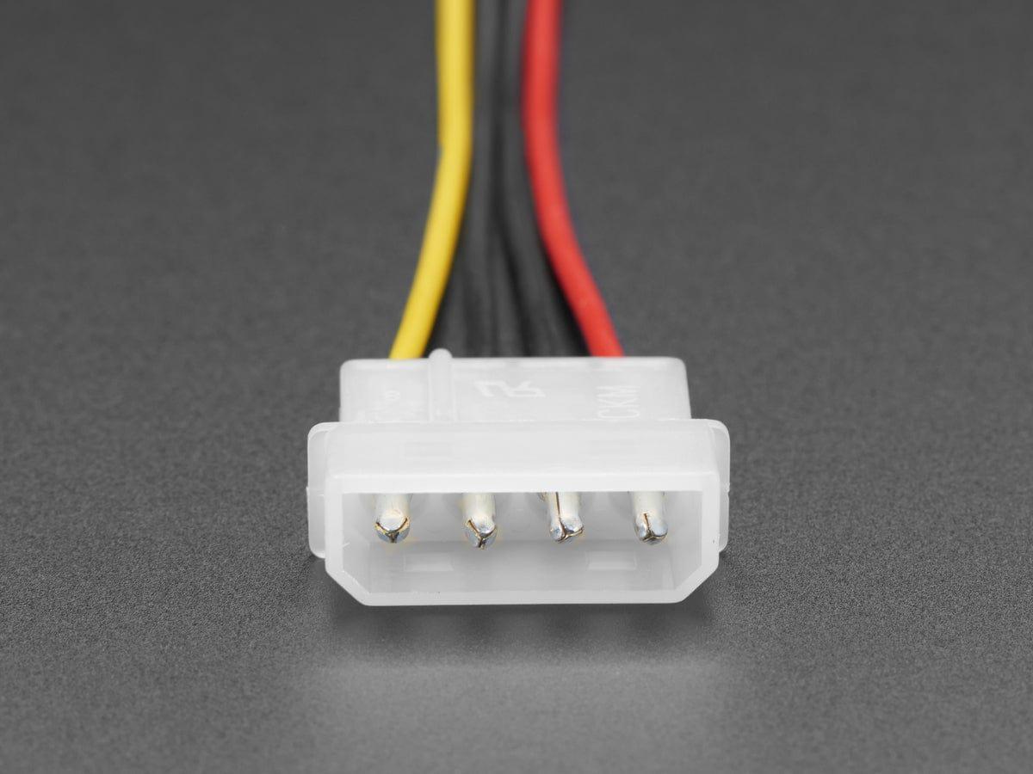
3. Molex 4-pin connector:

Devices powered: Older IDE hard drives, legacy optical drives, and compatible case fans.
Safety tip: Grip the plastic connector when removing it; never pull the wires.

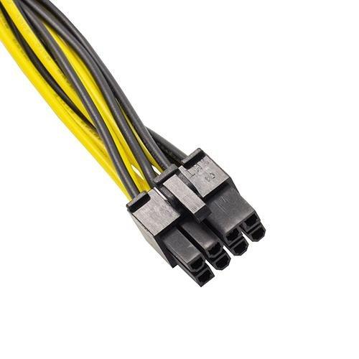
4. PCIe 6/8-pin graphics card connector:
Devices powered: Dedicated graphics cards (GPUs) that require additional power.
Safety tip: Use the correct PCIe power cable from the PSU, not the similar- looking CPU/EPS cable, and ensure the clip locks securely.

- Imagine you are setting up a new gaming PC. List the steps you would follow to connect the SMPS to the motherboard, graphics card, and storage devices, mentioning which specific cables and connectors are used for each.
Answer:

When setting up a gaming PC, I would follow these steps to connect the SMPS (Switched Mode Power Supply) to the motherboard, graphics card, and storage devices.
1. Switch off the power: Turn off the SMPS, unplug the power cord, and place the PC case on a stable surface.
2. Connect the motherboard: Connect the 24-pin ATX power connector from the SMPS to the motherboard's main power socket.
3. Connect the CPU power cable: Connect the 4-pin or 8-pin EPS/CPU power connector to the socket near the CPU on the motherboard.
4. Connect the graphics card: Connect the required PCIe 6-pin, 8-pin (6+2), or 12V- 2x6 power cable, depending on the graphics card model.
5. Connect the storage devices: Use 15-pin SATA power connectors from the SMPS to power SATA HDDs and SSDs. For older IDE drives, use a 4-pin Molex connector if required.
6. Check all connections: Ensure every connector is properly aligned and securely locked. Do not force any connector into a socket.
7. Start the computer: Close the case, reconnect the AC power cord, switch on the SMPS, and start the PC to verify that all components receive power.

